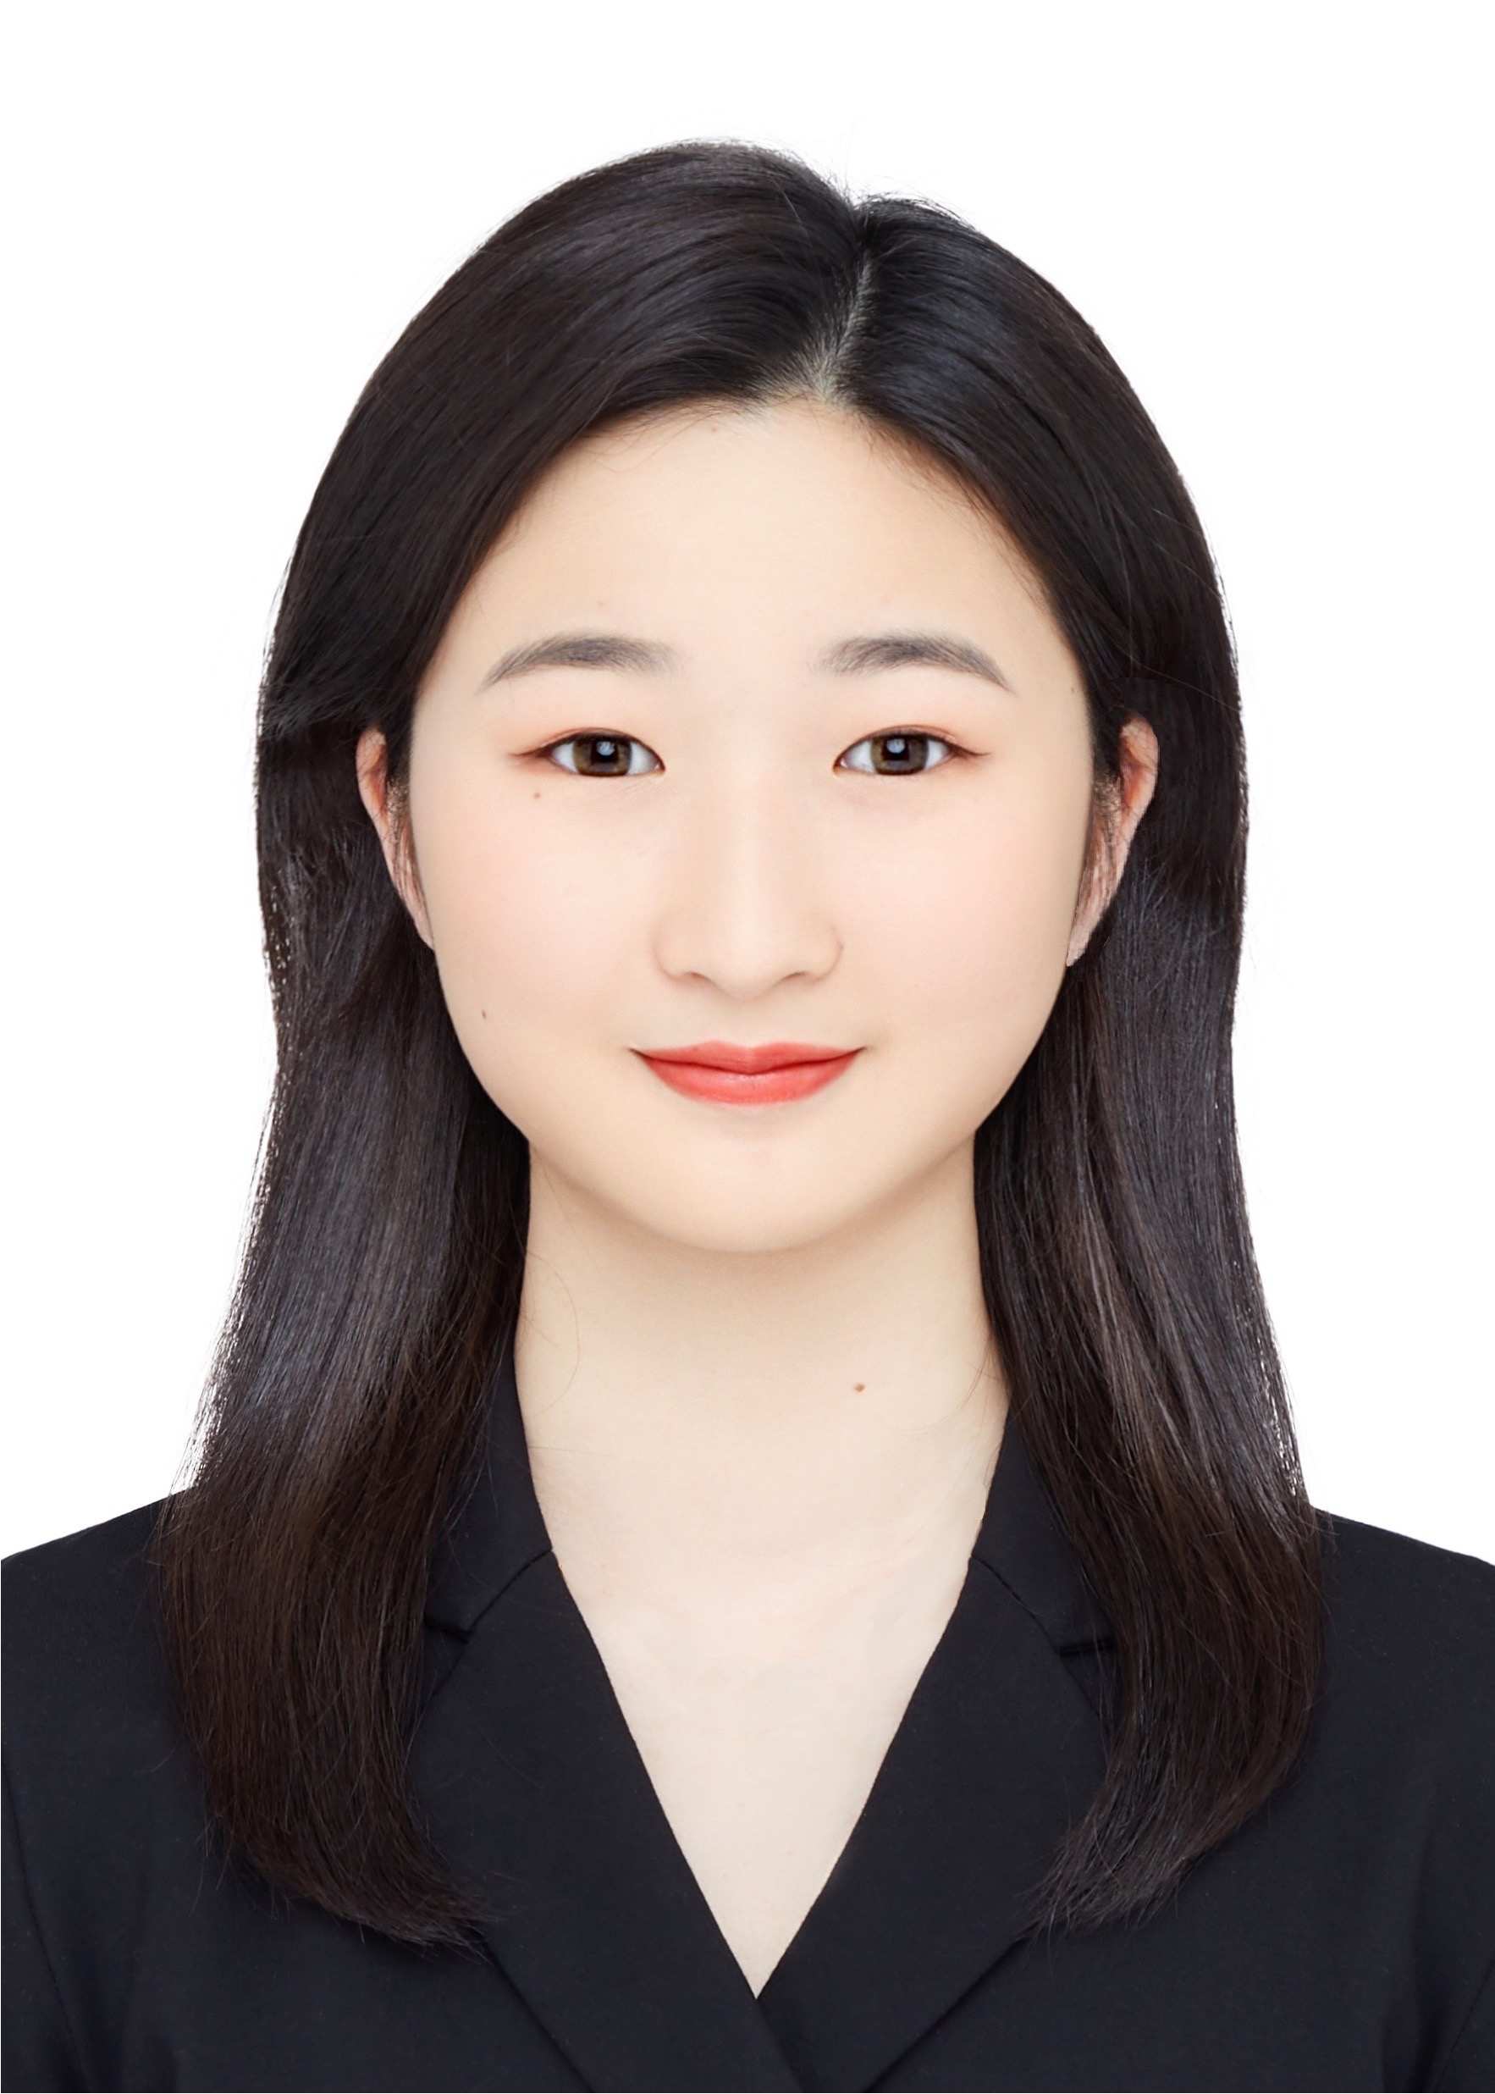
任皓韵 Rita Ren

教育经历
英属哥伦比亚大学 尚德商学院｜商业分析硕士 温哥华，加拿大，2025.08-2026.11
- 核心课程：业务分析数据管理（92%）、描述性与预测性业务分析（87%）、商业分析编程（85%）、数据可视化（84%）、数据驱动营销（81%）、机器学习
英属哥伦比亚大学 尚德商学院｜商学学士（荣誉） 温哥华，加拿大，2021.09-2025.05
专业：商业科技管理（辅修商业分析）
- GPA：3.95/4.33（专业前10%）
- 奖项： 杰出国际学生奖；赵莲与何锦恩纪念奖 (Chiu Lin & Grace Ho Memorial Award)
- 核心课程：管理信息系统（94%）、金融学（94%）、定量决策分析（94%）、物流与运营管理（89%）、国际商业管理（89%）、数据可视化与分析（87%）、管理与组织行为（86%）、编程与分析（85%）
实习经历
闳之美文化传播有限公司｜电商运营实习生 南京，2024.06-2024.08
公司简介：早期女性护理消费品牌，覆盖淘宝、抖音等平台，年销售额数十万元规模。
- 市场与竞品分析：以主流电商平台 TOP10 品牌与商品 为对标对象，拆解产品卖点、商详页逻辑与套组结构，识别可复制要素与差异化空间，为商品组合与卖点优化提供依据
- 用户与定价判断：基于用户调研数据，从使用场景、价格敏感度与关键购买要素切入进行用户细分，提出中低端定价 + 核心人群聚焦的新品策略，并结合品牌“植萃”定位明确温和、天然的差异化方向
- 增长与转化支持：结合行业趋势与社媒内容表现，提出内容型与测评型博主投放建议，相关优化方案推动转化率与用户满意度提升约 15%
国泰君安证券股份有限公司｜会计实习生 南京，2023.05-2023.07
部门概况：负责公司会计核算、财务数据管理及内部财务分析，支持集团层面分公司对比与管理决策
- 财务分析与对标：基于公司内部财务数据，协助构建统一分析口径与标准化报表框架，并对集团内分公司 成本、费用与经营指标 进行横向对比，识别关键差异与潜在风险点
- 管理决策支持：通过对经营指标波动与成本结构差异的分析，为部门内部管理分析及成本控制决策提供数据支持
- 数据与合规支持：使用 Excel 与财务系统整理会计凭证与档案，参与财务数据集中管理体系搭建，提升数据可追溯性与审计合规水平
校园经历
UBC 商德商学院｜CLC PASS Leader项目 温哥华，加拿大，2025.08-2026.02
- 教学效果分析：负责两门核心课程的辅导与教学设计，通过数据跟踪学生学习进度与共性难点，优化教学策略，学生课程满意度提升18%
- 项目增长与推广：主导项目宣传（线下活动 + 社媒平台），官方账号粉丝增长 3000+，学生出勤率同比提升 30%
UBC中商社｜人力资源主席 温哥华，加拿大，2023.05-2024.05
- 负责社团人力资源管理与组织结构优化，制定并推进继任计划，确保领导层连续性与组织稳定
- 主导大型活动与跨部门协作，组织 2 场新生活动，累计参与人次 300+
CUBS｜外联部干事 温哥华，加拿大，2022.12-2023.10
- 代表社团与供应商进行商务谈判，将单杯成本由 $9 降至 $5，并组织创新性筹款活动，用于支持社团公益项目
其他信息
- 语言能力：英语（Cambridge IPQ 等级A*，GRE 325，口语流利，可作工作语言）；法语/韩语/粤语（初级）
- 办公能力：熟练使用Python、R、SQL、Power BI、Tableau、Excel、Word、PowerPoint
- 兴趣爱好：中国舞、旅行、绘画、登山，网球
- 自我评价：相对属于沉稳型性格，性格乐观开朗，执行力较强，始终保持积极正向的工作态度。在面对挑战与压力时，能够快速适应变化，主动调整状态，并高效制定切实可行的解决方案。具备较强的亲和力与沟通能力，善于倾听他人意见，乐于分享经验，在团队中营造和谐、友好的工作氛围。工作中注重细节与执行质量，确保各项任务高标准完成。

Haoyun Ren (Rita)
Phone: (+86) 19951710492 | E-mail: renhaoyun20030219@163.com

Education Background

UBC Sauder School of Business | Master of Business Analytics Vancouver, CA, Aug 2025 - Nov 2026
- Key Courses: Data Visualization, Business Analytics Programming, Machine Learning, Predictive & Descriptive Analytics, Data-Driven Marketing, Info Tech Management, and Program Management.

UBC Sauder School of Business | Bachelor of Commerce with Honours Vancouver, CA, Sep 2021 - May 2025
- Business Technology Management with a Concentration in Business Analytics
- GPA: 3.95/4.33；Ranked top 10% ; 4 years’ Dean’s List
- Scholarships: Outstanding International Student Award; Chiu Lin & Grace Ho Memorial Award
- Key Courses: Management Information Systems, Finance, Quantitative Decision Making, Logistics and Operations Management, Management and Organizational Behavior, Programming and Analytics
Internship Experience

Hongzhimei Culture Communication Co.｜E-commerce operating Intern Nanjing, Jun 2024 - Aug 2024

Company Overview: Early-stage consumer brand in feminine hygiene and personal care, operating on Taobao and Douyin; annual revenue ~RMB 300,000–500,000
- Market & Competitive Analysis: Benchmarked Top 10 brands/SKUs across major e-commerce platforms to assess value propositions, PDP logic, and bundle structures, informing product bundling and messaging decisions.
- Customer & Pricing Insights: Analyzed user survey data to segment customers by usage scenarios, price sensitivity, and purchase drivers; supported mid-to-low pricing and core-customer focus aligned with the brand’s plant-based positioning.
- Growth & Conversion Support: Synthesized industry and social media performance data to recommend content- and review-driven influencer strategies, contributing to ~15% improvement in conversion and customer satisfaction.

Guotai Junan Securities｜Accounting Intern Nanjing, May 2023 - Jul 2024
- Financial Analysis & Benchmarking: Analyzed internal financial data and conducted cross-subsidiary comparisons on costs, expenses, and key operating metrics; supported management analysis by identifying material variances and potential risk areas.
- Management Decision Support: Contributed to the development of standardized reporting frameworks and consistent analytical methodologies to improve comparability and internal decision-making.
- Data & Compliance Support: Maintained accounting records using Excel and financial systems, supporting centralized data management, audit compliance, and process standardization.
Extracurricular Activities

UBC Sauder School of Business｜CLC PASS Leader Vancouver, CA, Aug 2025 - Feb 2026
- Learning Effectiveness Analysis: Designed academic support and review sessions for two core courses; applied data analysis to track learning progress and identify common challenges, improving student satisfaction by 18%.
- Program Growth & Engagement: Led program promotion through on-campus events and social media, growing the official account by 3,000+ followers and increasing attendance by 30% YoY.

UBC BizChina｜HR chair Vancouver, CA, May 2023 - May 2024
- Led HR management and team structure optimization; developed and implemented a succession plan to ensure leadership continuity and organizational stability.
- Drove large-scale events and cross-functional collaboration, organizing two new-member events with 300+ total participants.

UBC CUBS｜Fundraising Coordinator Vancouver, CA, Dec 2022 - Oct 2023
- Represented the society in vendor negotiations, reducing beverage costs from $9 to $5 per unit, and organized innovative fundraising initiatives to increase visibility and support community-focused activities.
Additional Information
- Language: English (GRE 325, working proficiency); Mandarin (native); French / Korean / Cantonese (basic)
- Technical & Analytical Skills: Python, R, SQL, Power BI, Tableau, Excel, Word, PowerPoint
- Interests: Chinese dance, travel, drawing, hiking, tennis

